INTRODUCTION
Strokes are a major cause of death and long-term disability. This has had an affect on my family and countless others. As stroke risk factors are recorded in healthcare, I believe I will be able to use supervised classification models to evaluate risk prediction. My goal in this project is to explore if classification models can separate higher-risk individuals from lower-risk individuals.
Logistic regression is a good starting point because it is simple and easily interpretable. However, real healthcare data often involve nonlinear patterns and interactions (for example, risk increasing sharply after certain ages). Therefore, as machine learning methods are more flexible it can sometimes improve predictive performance, although this will sacrifice interpretability. In this report, I compare a baseline model against more flexible approaches, including a deep learning model, to see whether the more complex models are better at prediction for this dataset.

My Approach
After I completed exploratory checks and preprocessing, the data was split into training and test sets using a stratified split. I will be comparing three classification models will be fitted and compared, which are logistic regression (GLM), support vector machine (SVM) and a feed-forward neural network (deep learning)
Models are evaluated on the test set using with focus on sensitivity, specificity, AUC and accuracy. This can give a fair comparison and will tell us whether the models can meaningfully improve identification of stroke cases.

EXPLORATORY DATA ANALYSIS
I carried out the EDA to examine what is in the dataset, to check the quality of the data, and to identify anything that could affect training or evaluation. The dataset for strokes contains 5,110 observations and 12 variables (Figure 1). The response variable is stroke, and the predictors include a mix of numerical variables (age, average glucose level, BMI) and categorical variables (gender, work type, smoking status) shown in Figure 2.
Class imbalance
I found that the outcome is extremely disproportionate. There are 4,861 non-stroke cases compared to 249 stroke cases shown in Figure 3. This implies that overall accuracy on its own may not be a reliable measure of performance, as a model can achieve high accuracy by predicting the majority class most of the time. Because of this, the evaluation focuses on sensitivity, specificity, and AUC.
Missing values and data quality
The only variable with missing values is BMI, with 201 missing observations (3.9% of all the BMI data). None of the other predictors have missing values. Since the missing BMI data is small, I will use median imputation to address this issue.

Numerical predictors
- Age (Figure 7) shows the most obvious separation. Individuals with stroke are much older on average. This is shown by the median age being 71 in the stroke group in comparison to 43 in the non-stroke group.
- Average glucose level (Figure 8) is also higher for stroke cases. The median is over 100 for those who have had a stroke, whereas its around 90 for those in the non-stroke group. The glucose variable has a noticeable right tail , which means outliers are present. But this understandable in a healthcare context.
These patterns suggest that stroke risk in this dataset is likely driven by age and is also associated with physiological parameters
Categorical predictors
- The marital status variable shows higher stroke frequency for yes compared to no, which is likely reflects the age distribution.
- Smoking status has an “unknown” category (which is not missing data). The highest observed stroke prevalence is among the formerly smoked variable, then smokes and never smoked, while the unknown category is the lowest.
- The type of job varies, with self-employed showing a higher observed stroke amount than other groups. However, these differences are likely mixed in with age and retirement/working patterns rather than being purely causal.

EDA and preprocessing
Based on the EDA, I chose to remove the ID variable (as it has no relevant information), converting categorical predictors into factors for modelling, using median imputation for missing BMI values, using a stratified 70/30 train–test split to preserve the class imbalance in both sets, and standardising numerical predictors for models that are sensitive to scale.

DATA PREPROCESSING
Following the exploratory analysis, several preprocessing steps were applied to prepare the data for modelling and to ensure that all models were trained and evaluated on a consistent basis.
- The ID variable was removed because it is only an identifier and does not contain helpfull information.
- The stroke variable was treated as a binary outcome (0 = no stroke, 1 = stroke). All categorical predictors were converted to factor variables so they could be handled correctly in the modelling workflow. Where models required numerical inputs, categorical variables were represented using dummy variables
- The only variable with missing values was BMI. Since the proportion of missing BMI values was small, missing BMI entries were replaced using median imputation.
- To assess out-of-sample performance fairly, the dataset was split into training (70%) and test (30%) sets using a stratified split so that the stroke/non-stroke proportions were preserved in both subsets. This is especially important here because the response is strongly imbalanced.
- Numerical predictors were standardised where required. Standardisation is essential for methods that rely on distances or dot products.
This produced a clean dataset and allows the different classification methods to be compared fairly.

MODELS AND METHODOLOGY
To make the comparison meaningful all models were trained on the same training set and evaluated on the same test set. The methods were chosen to represent a progression from a simple, interpretable baseline to more flexible machine learning and deep learning models that can capture nonlinear patterns.
Generalised Linear Model
Logistic regression was chosen as the baseline classifier because it is widely applied in medical prediction and provides easily interpretable outputs. Stroke is a binomial response variable and the GLM models the log-odds of stroke using a logit link function. All of the predictors were included in the model so that it could be a benchmark for comparison.
The fitted model creates predicted probabilities of stroke for each individual in the test set. For classification, the probabilities were converted into class labels using a 0.5 threshold. Although logistic regression is easy to understand, it assumes that the relationship between predictors and the log-odds of stroke is linear, which can limit performance if the relationships are nonlinear and/or complex.
Support Vector Machine
A support vector machine with an RBF kernel was fitted to consider nonlinear decision boundaries. SVMs work by finding a separating boundary that maximises the margin between classes, and the kernel approach allows the boundary to become nonlinear without manually creating interaction terms.
SVM performance is sensitive to variable scale, because of this, predictors were centred and scaled as part of the training pipeline. I tuned the hyperparameters by using 5-fold cross-validation in the training set, and the tuning objective was made to maximise ROC-based performance. The tuned SVM was used to generate class predictions and probabilities on the test set.
Deep Learning Model: Feed-Forward Neural Network
A feed-forward neural network was used to explore whether a more flexible model could better capture nonlinear patterns and interactions in the predictors. Categorical predictors were converted using one-hot encoding so that the network could be trained on a fully numeric feature matrix.
I used two hidden layers for the network architecture by using with ReLU activation functions, then I used sigmoid output layer to produce stroke probabilities. To reduce overfitting, I applied dropout regularisation between layers. I trained the model using the Adam optimiser with a binary cross-entropy loss function over 50 epochs, using a validation split from the training data to monitor learning during training.
As the dataset is extremely disproportionate, class weights were used during training so that misclassifying the minority class was penalised more heavily than misclassifying a majority class. This decreases the chance that the network favours the majority class and to improve sensitivity for detecting stroke.
All together, these models provide a structured comparison across different levels of complexity. Where logistic regression is used as an interpretable benchmark, SVM is used as a tuned nonlinear machine learning classifier, and a neural network is used as a flexible deep learning approach. Their performance is compared in the next section using evaluation measures that are appropriate for imbalanced medical classification tasks.

Model Evaluation and Comparison
Model performance was assessed on the test set. Alongside overall accuracy, I looked at sensitivity for the stroke class, specificity for the non-stroke class, and balanced accuracy. Also, the area under the ROC curve (AUC) is used to compare model as it evaluates how well predicted probabilities rank stroke cases above non-stroke cases.
The table below summarises test-set performance:
Model | Accuracy | Sensitivity (stroke) | Specificity (no stroke) | Balanced Accuracy | AUC
GLM | 0.952 | 0.014 | 1.000 | 0.507 | 0.848
SVM | 0.951 | 0.014 | 0.999 | 0.506 | 0.580
Deep Leaning | 0.731 | 0.662 | 0.735 | 0.698 | 0.806
Table created by Figure 12, Figure 13, Figure 14

Accuracy has proven to be misleading. Both logistic regression and the SVM achieve accuracy around 0.95, but this appears to be by correctly classifying the majority non-stroke cases. At a 0.5 classification threshold, both models identify only 1.4% of stroke cases (sensitivity 0.014), meaning they would miss the majority of strokes. This is reflected in their balanced accuracy values, which are close to 0.5, which indicates poor class separation, nearly equivalent to a coin flip.
The deep learning model provides a much more useful outlook under the same threshold. It increases stroke sensitivity to up to 0.66, meaning it correctly identifies around 66% of stroke cases. This improvement comes with a reduction in overall accuracy (around 0.73) because the model produces more false positives among non-stroke individuals. This is better for healthcare as it is often an acceptable trade-off because false negatives are more costly than false positives, especially if the model is intended to catch individuals who need further clinical assessment.
The ROC/AUC comparison shows that logistic regression achieves the highest AUC 0.848, with deep learning close at 0.806, while the SVM performs substantially worse at 0.580. This suggest that logistic regression ranks cases reasonably well overall, but is still extremely bad at stroke detection. This reinforces that for imbalanced outcomes, a strong performance often requires both an appropriate modelling approach and a decision threshold chosen to prioritise sensitivity.

DISCUSSION
The results show why stroke prediction is a challenging classification problem. The outcome is rare, so a model can look good on accuracy while still being useless for detecting stroke cases. Both logistic regression and the SVM achieved very high test accuracy, but at the default 0.5 threshold they predicted almost everyone as non-stroke, leading to extremely low sensitivity for the stroke class. These models mainly learned the majority class and did not generate enough high-probability stroke predictions to cross the decision threshold.
Nevertheless, logistic regression achieved the highest AUC which suggests it was reasonably good at ranking people by risk, but due to the threshold it wasn’t good at detecting the minority class. This tells us that performance depends on the model and the decision rule. A lower threshold, or a rule based on maximising sensitivity subject to a false-positive constraint, could make logistic regression much more useful, while keeping its interpretability. The deep learning model produced a clinically relevant trade-off. It placed more emphasis on correctly identifying stroke cases and achieved substantially higher sensitivity. The cost of this improvement was lower specificity and therefore lower overall accuracy. This trade-off is often acceptable, because false positives can be filtered later, while false negatives represent missed opportunities for early intervention.
The SVM performed poorly looking at the AUC, which suggests that the tuned decision boundary did not do a good job at ranking stroke risk. This could be caused by the imbalance, or sensitivity to tuning choices. It also shows that more complex models do not automatically outperform simpler approaches.
Limitations
- Severe class imbalance can create bias training toward the majority class.
- Single split evaluation can be sensitive to how the data were partitioned; repeated cross-validation would give a more stable estimate of performance.
- Limited feature set can be a problem as the dataset lacks a large amount of clinical details so there is a cap on achievable performance.
- Potential confounding some predictors (e.g., marital status, work type) may proxy age and social factors rather than directly driving stroke risk.

CONCLUSION
When I started this project I wanted to see whether machine learning and deep learning methods can improve stroke prediction compared with a logistic regression baseline. The results show that relying on accuracy alone is misleading as both logistic regression and the SVM achieved very high accuracy, but at the 0.5 threshold they identified almost no stroke cases, which resulted in extremely low sensitivity. Logistic regression achieved the strongest AUC, which suggest it ranked individuals risk reasonably well, even though its default decision threshold was not suitable for detecting the minority class.
The deep learning model produced the most beneficial behaviour. It significantly increased sensitivity for stroke detection, at the cost of more false positives and a lower overall accuracy. Given that missed stroke cases are typically more costly than false alarms, this trade-off is preferable when the objective is early flagging rather than final diagnosis.

Appendix

Figure 1

Figure 2

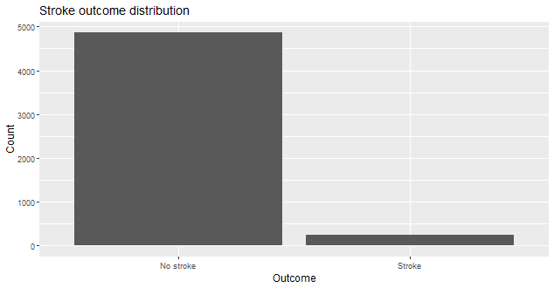
Figure 3

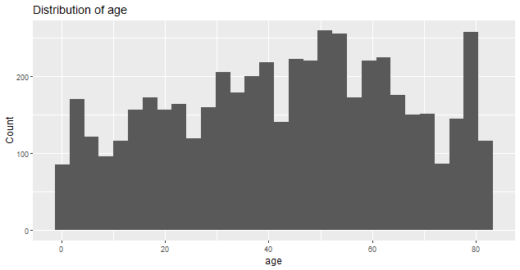
Figure 4

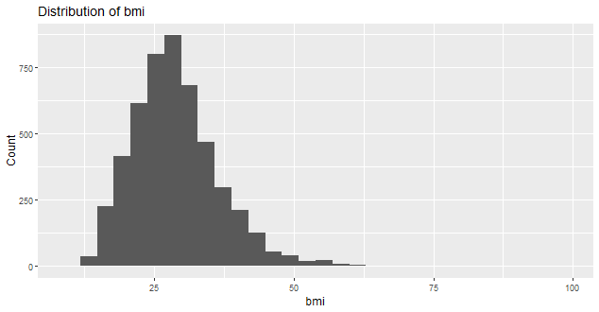
Figure 5

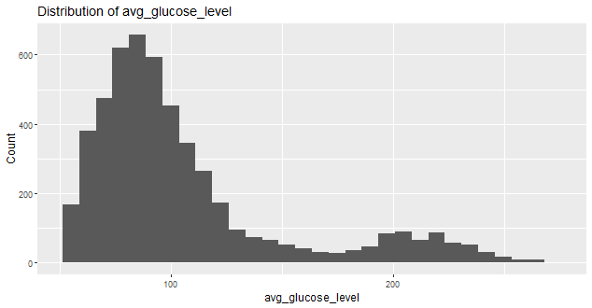
Figure 6

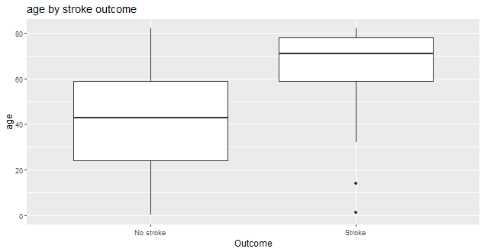
Figure 7

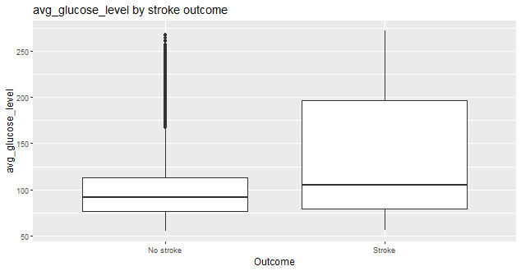
Figure 8

Figure 9

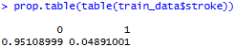
Figure 10

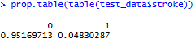
Figure 11

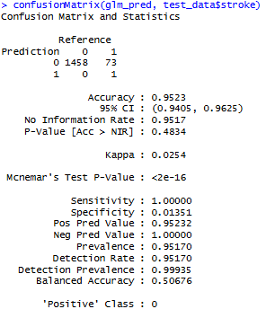
Figure 12

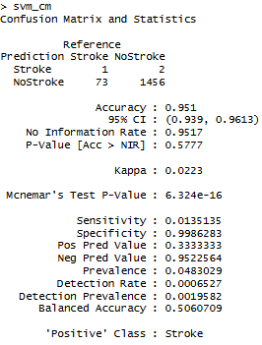
Figure 13

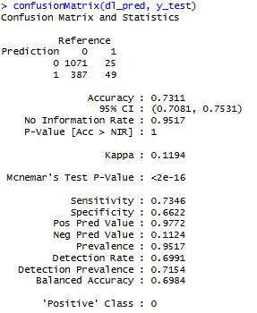
Figure 14

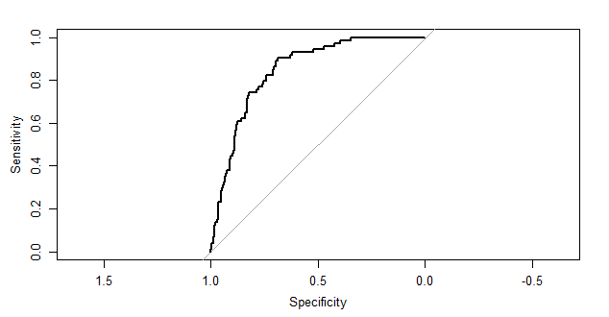
Figure 15

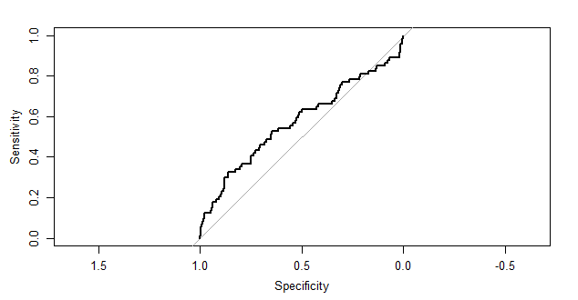
Figure 16

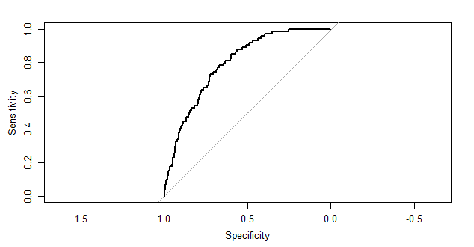
Figure 17

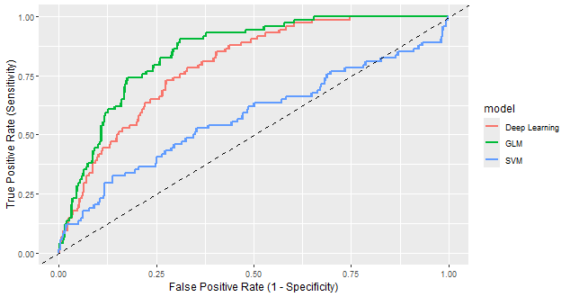
Figure 18
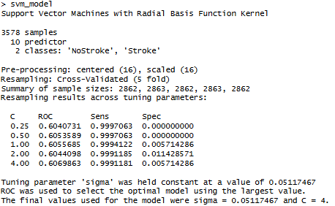
Figure 19
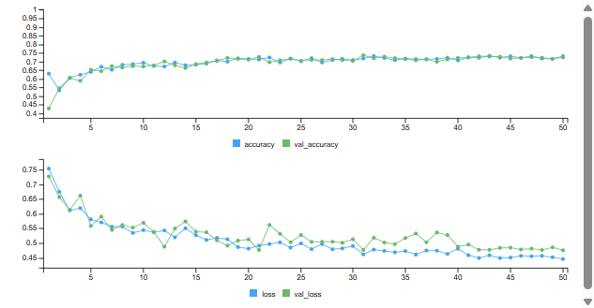
Figure 20

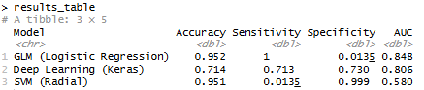
Figure 21

